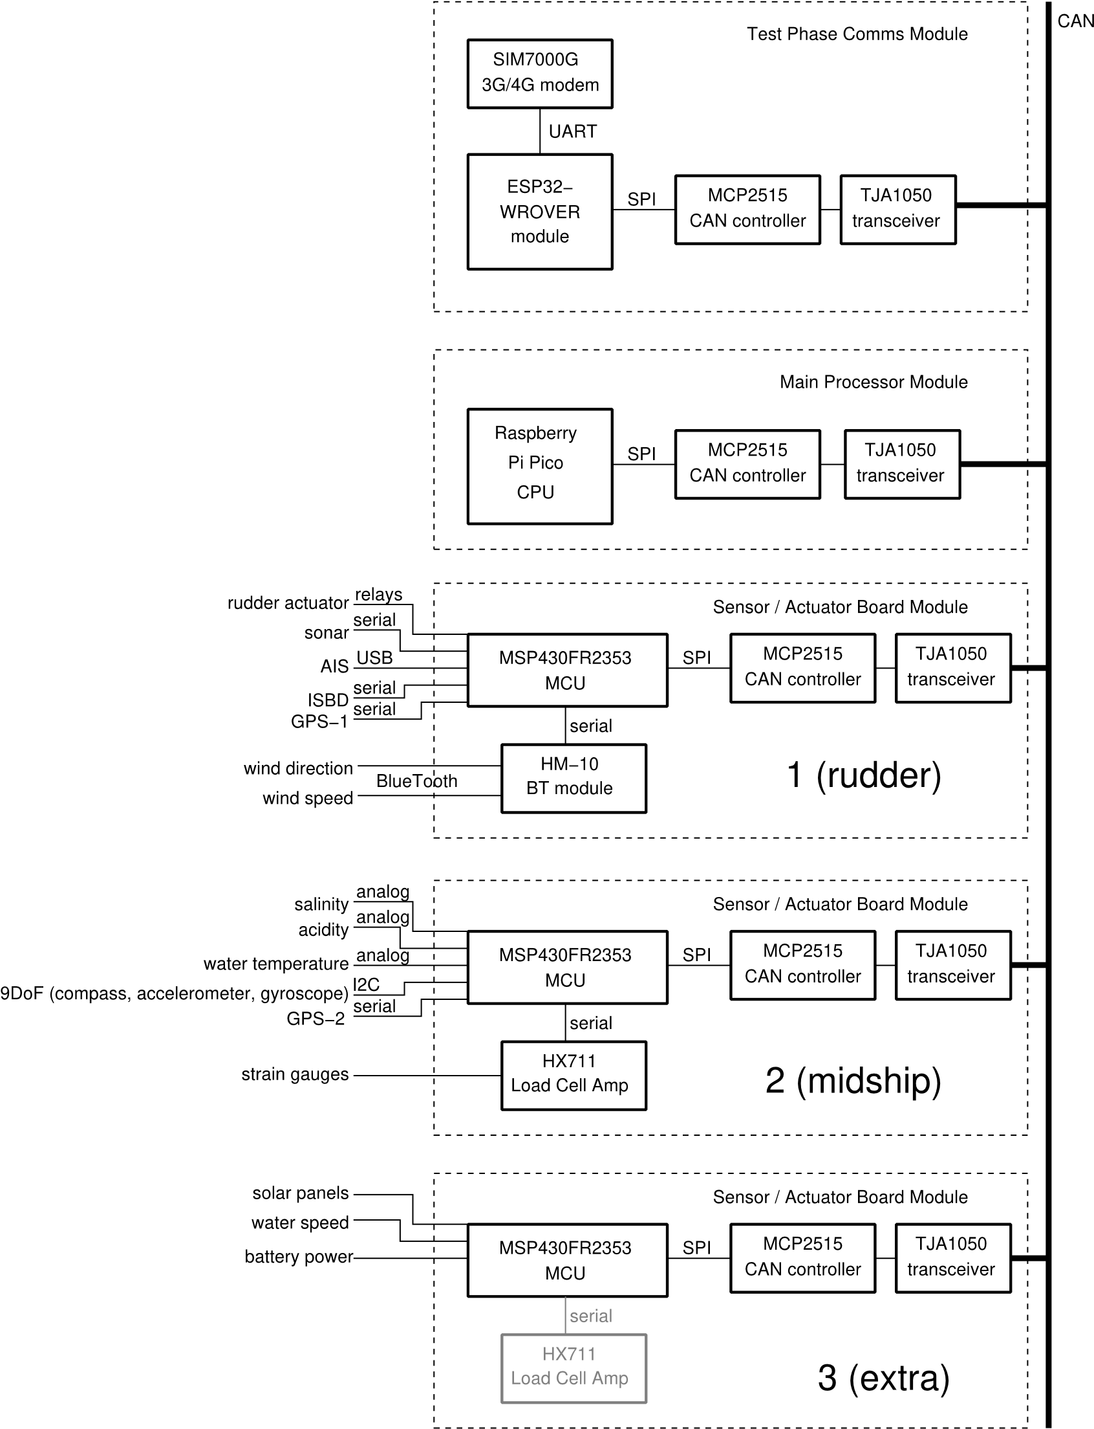

Uitgaand van bovenstaand ontwerp heeft de sensormodule die ontworpen moet worden de volgende functionaliteiten:

* CAN-Bus Interface via SPI communicatie
* Magneetcompas Via I2C communicatie
* Dataoverdracht van magneetcompas via CAN-Bus

I2C

SPI

Microcontroller

Magneetcompas

CAN-Bus Interface

Magneetcompas > NMEA2000 > CAN-Bus

CAN-Bus Module

CAN-Extended

NMEA-2000

Conversie

Microcontroller

Magneetcompas

9-DOF Magneetcompas waardes die in NMEA-2000 protocol te stoppen zijn:

Pitch/Roll(PGN127257?)

|  |
| --- |
|  |
| { |
|  | "Order":3, |
|  | "Id":"pitch", |
|  | "Name":"Pitch", |
|  | "BitLength":16, |
|  | "BitOffset":24, |
|  | "BitStart":0, |
|  | "Units":"rad", |
|  | "Resolution":0.0001, |
|  | "Signed":true}, |
|  | { |
|  | "Order":4, |
|  | "Id":"roll", |
|  | "Name":"Roll", |
|  | "BitLength":16, |
|  | "BitOffset":40, |
|  | "BitStart":0, |
|  | "Units":"rad", |
|  | "Resolution":0.0001, |
|  | "Signed":true}]}, |

Heading van de neus(PGN127250, bits 8–23 en bit 56–57?)

|  |
| --- |
| { |
|  | "Order":2, |
|  | "Id":"heading", |
|  | "Name":"Heading", |
|  | "BitLength":16, |
|  | "BitOffset":8, |
|  | "BitStart":0, |
|  | "Units":"rad", |
|  | "Resolution":0.0001, |
|  | "Signed":false}, |